EXPERIMENT NO.: - 3

AIM: Writing SQL Statements using SQL Compiler.

1. **Creating Table using CREATE Query Input:**

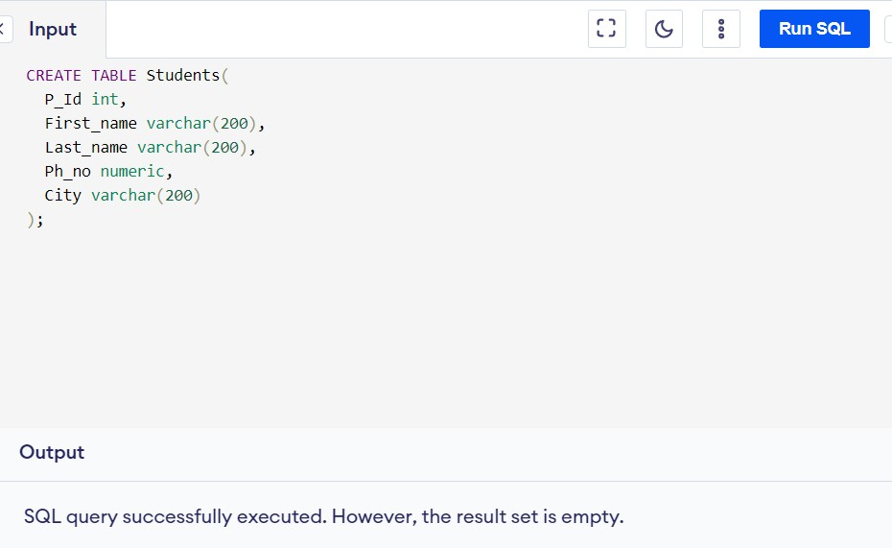

1. **Inserting Data into the Table Input:**

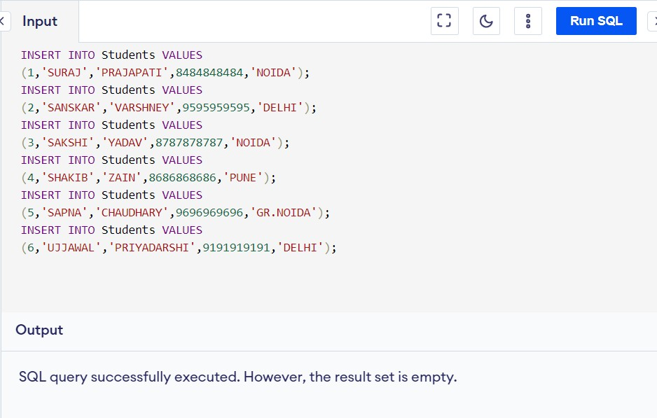

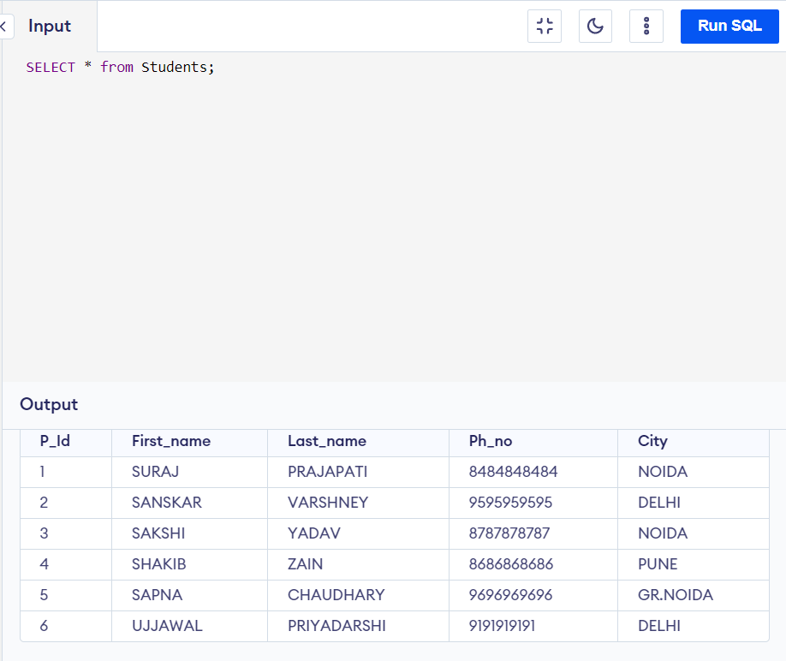

4. Updating the Data using UPDATE Query Input:

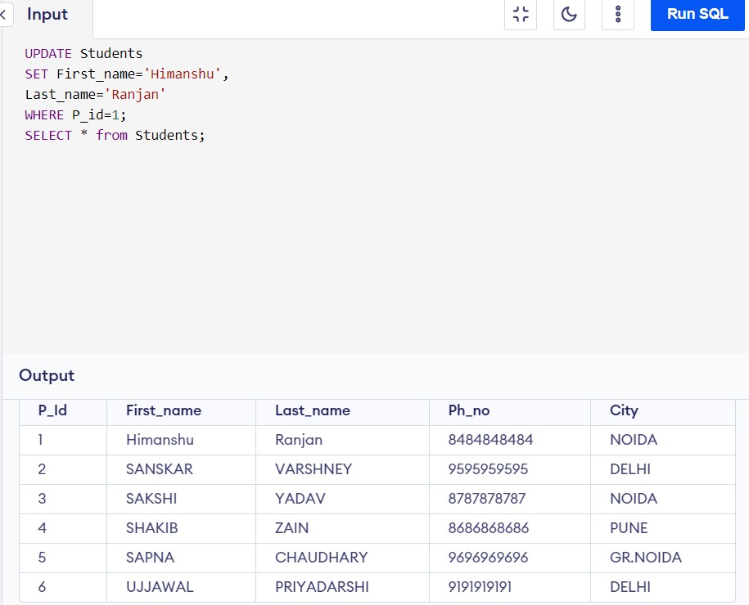

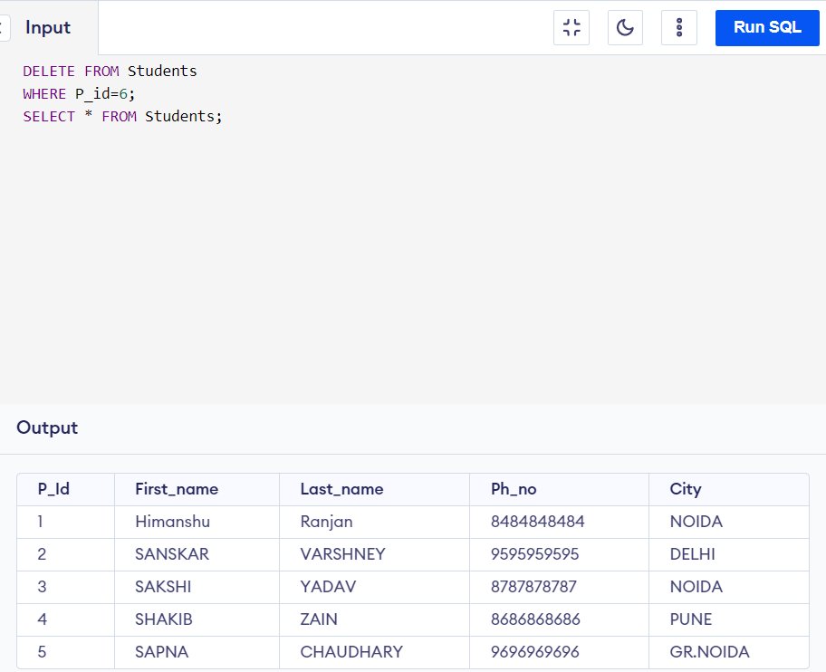

6. Modification in Table (deleting a column) using ALTER Query Input:

